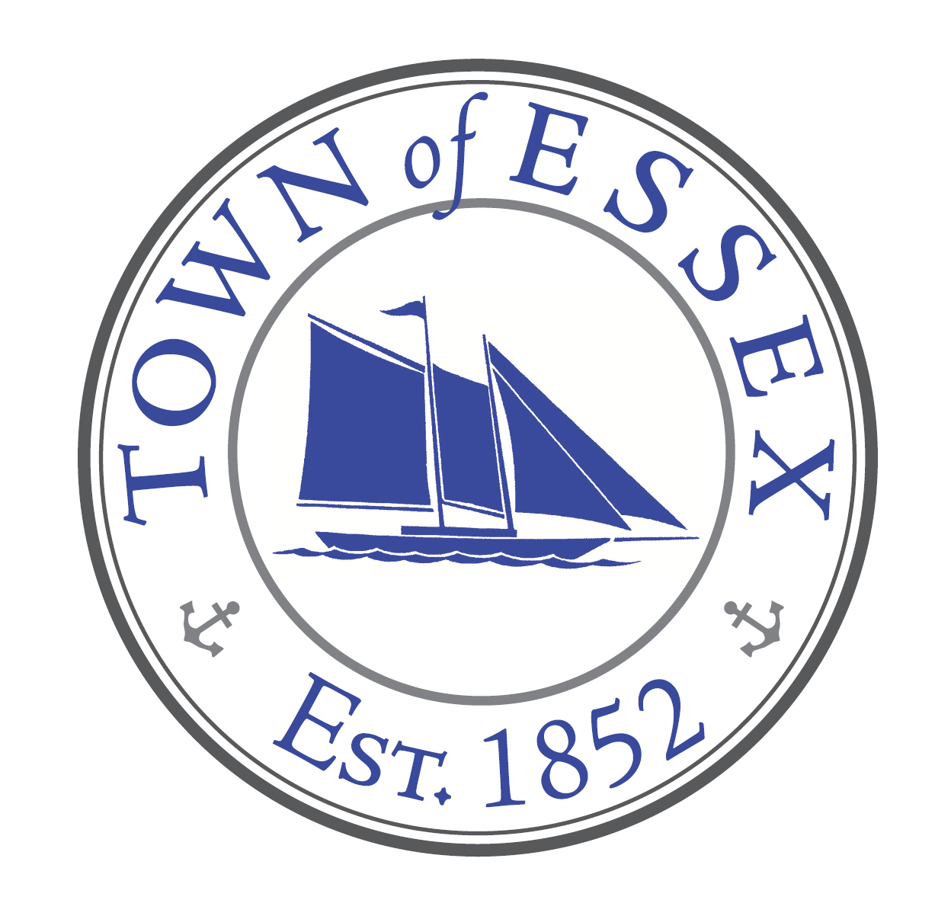

Ad Hoc Committee – Thatchbed Island
www.essexct.gov

Jeff Going, Chairman Essex Town Hall
Bruce Glowac 29 West Avenue
Bob Robinson Essex, Connecticut 06426
Paul Greenberg Telephone: 860-767-4340
Harwood Comstock Fax: 860-767-8509

Notice of meeting: Wednesday, August 10, 2022 4:00 pm

Onboard Bruce Glowac’s boat (in front of ECYC) and will view rock piles and staked areas up close.

