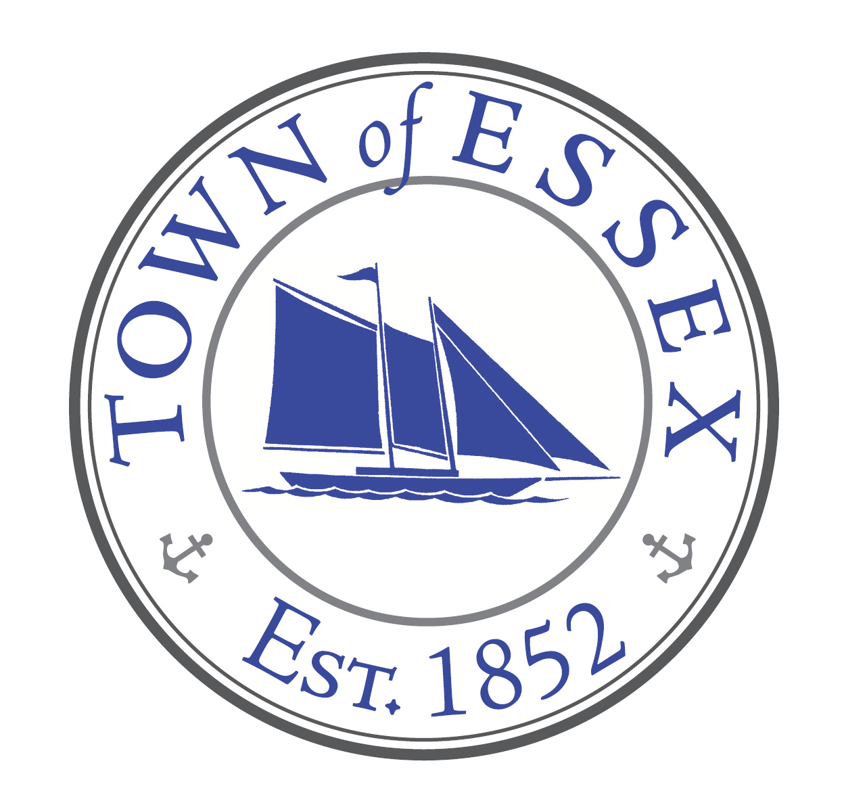

Ad Hoc Committee – Thatchbed Island
www.essexct.gov

Jeff Going, Chairman Essex Town Hall
Bruce Glowac 29 West Avenue
Bob Robinson Essex, Connecticut 06426
Paul Greenberg Telephone: 860-767-4340
Harwood Comstock Fax: 860-767-8509
Kathleen Sealey

Meeting: Monday, July 10, 10 am @ Essex Yacht Club

Attendance: Jeff Going, Bruce Glowac, Paul Greenberg, Harwood Comstock

Reviewed and updated:

Rock relocation - received COP #202304100 - waiting for Connecticut River Dock & Dredge …

Kathleen has provided communication outline for our proposed demonstration restoration for our review and input - will give us revised and updated version this week.

Discussed various options for restoration plans making “beneficial use of dredge material”.

Reviewed meeting with DEEP’s Andy Fisk and Brian Thompson, Norm Needleman, Bruce Glowac and Jeff Going on July 5. DEEP appears very interested in this project as a “Demonstration Project” and would like to see us work with a specialty environmental engineering company. Once Essex gets this a little more defined, we will go to an RFP. Andy Fisk will get a tour of Essex Harbor in the near future to better understand the situation. State/Federal monies available…

Once rocks are moved we can get better communications on our plans for restoration. Potential articles for Essex Events, Land Trust news, possibly Estuary.

Building relations with “Partners” and “Stake Holders”. Will include invitations to future meetings and distribution of minutes and other communications.

Next meeting planned for August.

No motions taken.

